../../Screen%20Shot%202017-10-19%20at%2011.46.21%20AM.png../../Screen%20Shot%202017-10-19%20at%2011.45.30%20AM.png../../Screen%20Shot%202017-10-19%20at%2011.44.21%20AM.png../../Screen%20Shot%202017-10-19%20at%2011.43.44%20AM.png../../Screen%20Shot%202017-10-19%20at%2011.42.18%20AM.png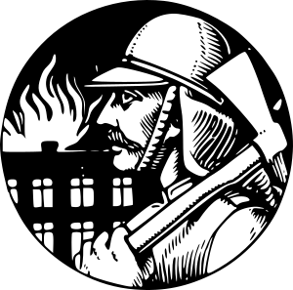

The job of a firefighter is one of danger. Advancements in technique, training, and equipment have made the job safer to a degree, but the danger is still ever present. This fact makes the work done by brave firefighters living at the turn of 20th century even more impressive. They were forced to face the same dangerous with only the most basic equipment and understanding of the physical riggers that they were being subjected to.

When we think of the equipment that our firefighters rely on we think trunks, insulated suits, and sophisticated water pumping systems. But what the New York City firefighters of the 1920s counted on most were their horses. The speed, strength, and discipline of the horse teams pulling the fire engines could mean the difference between life and death. Because of this, a fire company’s horses were well cared for and their loyalty and dedication rewarded. A fire horse was a dedicated creature and always sad when a veteran steed was forced to retire. In many ways the horses that got the personnel and equipment to the fires deserved to be called heroes as well.

It wasn’t just primitive equipment that firefighters of the day had to deal with; the lack of regulation in most cities’ departments often meant that firefighters were overworked. In New York City at the time, for example, it was ordinary for a firefighter to spend 9 out of 10 days on days—leaving little time for rest or family.

Published Oct. 17, 2011 | doi: 10.1234/5678-9123.4.5.6

By Kellen West

Unsung Heroes

Partners

Scholarships

Initiatives

Site map

Contact us

Archives

Editorial staff

Awards

About us

Home page

Journal *of* Firefighting

*A Chronicle of heroism*

Main Menu

dsfsdfsdf